#### ****Lab IX – Health Analytics II****

**Exercise 2.1 Incidence rates**

*Document a screenshot and the URL of your analysis*

URL:

<http://gt-health-analytics-2.us-east-2.elasticbeanstalk.com/#/iranalysis/42>

Screenshots:

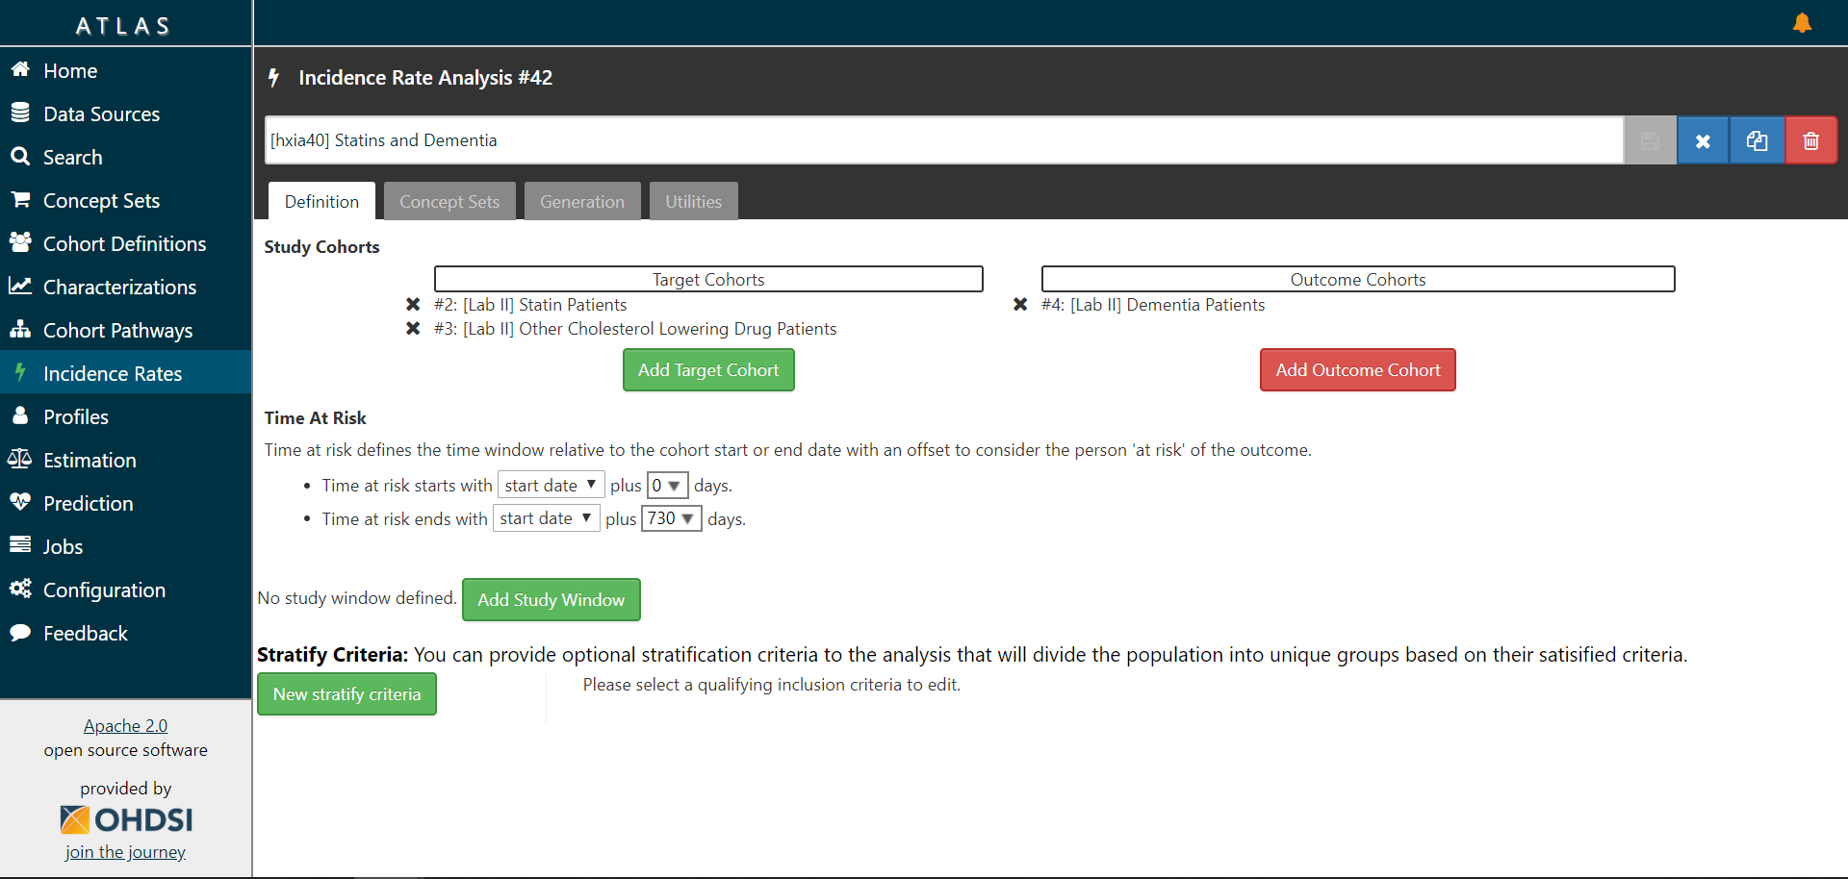

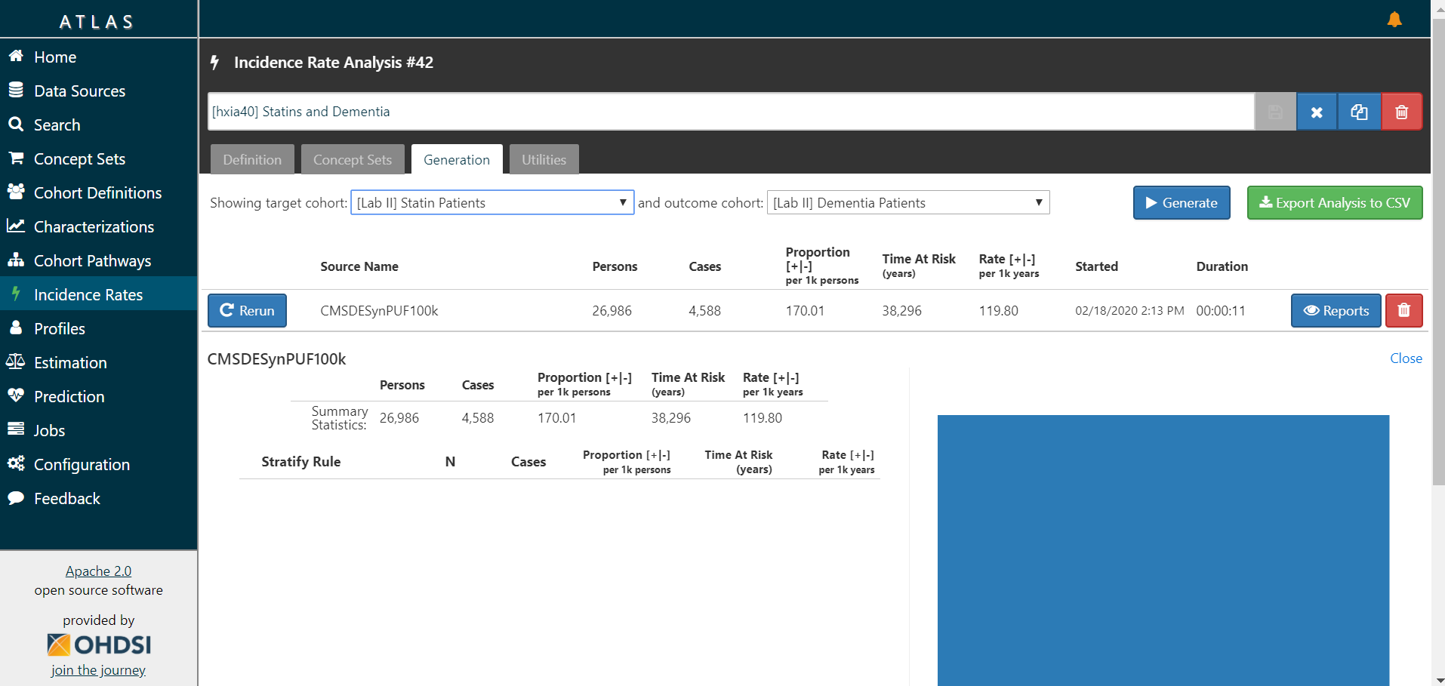

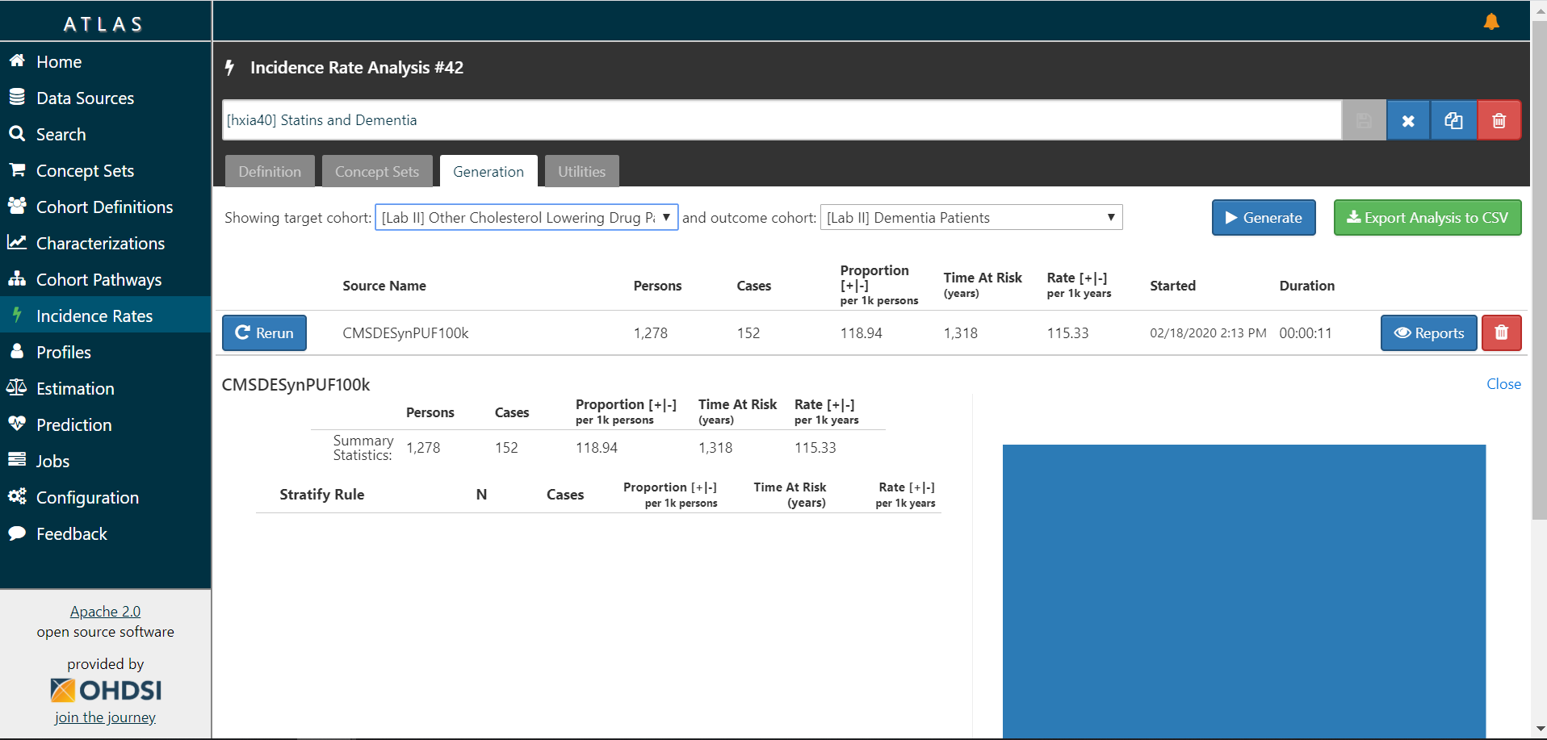

**Exercise 2.2 Characterizations**

*What is the age group with the greatest difference (Std Diff) between the Statin users and Other Cholesterol drug users?*

40-44

*What condition shows the greatest difference between Statin Users and Other Cholesterol drug users?*

Pure hypercholesterolemia

*Document a screenshot and the URL of your analysis*

URL:

<http://gt-health-analytics-2.us-east-2.elasticbeanstalk.com/#/cc/characterizations/37/design>

Screenshots:



